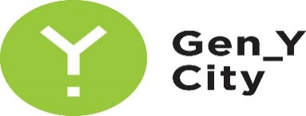
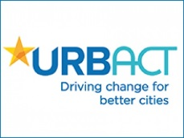
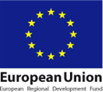

A research aiming to find out the understanding of citizens and students of Daugavpils, as well as those, who work in the city, about the creative industries and the city’s creative potential was carried out in the city of Daugavpils within the framework of the project „Gen-Y City”/“Get into the swing of the City!”, supported by URBACT III programme of the European Regional Development Fund.

Within the research a survey was conducted, involving 502 respondents, whose place of residence, work or study is connected with the city of Daugavpils. Daugavpils is a place of residence and work for 67% of respondents. While for 4% the city of Daugavpils is only a place of work.

The highest activity was within the group of respondents within the age from 26 to 30 years – 25% of the total number of respondents. Women were twice more active than men – 70% of the total number of respondents.

During the survey, the respondents expressed their opinion about creative places and events in the city, about popular tourism sites and about future development perspectives for the city of Daugavpils.

According to respondents` belief, a creative city is characterized by cultural institutions and cultural events, creative activities, communities of craftsmen and artists in the city. Respondents believe that the City Council (23 %), cultural institutions (22 %) and creative citizens (14 %) are responsible for the development of creative environment in Daugavpils. 11 % of respondents believe that any citizen or society, in general, in the city is responsible for the development of creative environment.

Respondents believe that in order to develop various creative initiatives in the city, Daugavpils city municipality should develop a more creative urban environment (14 %), provide more support to cultural events and create the centre of creative industries (13 %), as well as finance the development of small entrepreneurs (10 %).

Respondents, for example, consider Daugavpils Theatre – 20 %, cultural and tourism institutions – 17 % and Daugavpils Fortress – 15 % as creative places in the city. Libraries and cafes, where concerts, exhibitions and other cultural and educational activities not typical for such places are organized, was mentioned as creative places several times.

The following events in the city of Daugavpils were named as the most popular:
- City Festival (28 %);
- Night of Museums (15 %);
- speedway (14 %);
- events at the Rothko Centre (10 %).

Several times respondents suggested that citizens should participate as much as possible in the development of the city, that society and municipality should be more open for cooperation and partnership.

The participants of the survey believe that the prospects for the development of the city of Daugavpils lie within the culture and art sector (27 %), tourism (24 %), as well as education and science (15 %).

The results of the research will be integrated into the planning document of the project which is developed in order to maintain, attract and develop creative people in Daugavpils.

Let’s make Daugavpils a city, whose residents have diverse perception, a city with stylish ambience, a city, where its vibration can be heard in the streets.

